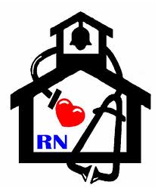
Nurse’s Nook
Pearl Lower Elementary – April
Aly Weems, School Nurse
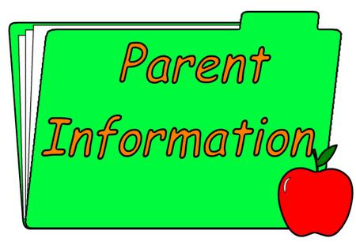 Parent Information
Be a Tobacco-Free Role Model
- Don’t start smoking or use tobacco and nicotine products.
- Take an active interest in your child’s social life. Know your child’s friends.
- Teach your children to be aware of how tobacco products are promoted in the media.
- Think beyond cigarettes. Smokeless tobacco, hookahs, e-cigarettes, and other flavored tobacco products are addictive, too.

Protect Children from Secondhand Smoke
- Don’t allow smoking in the home or car.
- Don’t allow caregivers to smoke around your children or in your home.
- Insist on smoke-free restaurants and other public places.

Resources for Quitting Tobacco Use
- www.askandact.org
- www.familydoctor.org
(click on “Diseases and Conditions” then “T” for Tobacco Addiction)
- www.smokefree.gov
- www.tobaccofreekids.org
- 1-800-QUITNOW or 1-800-784-8699

